**Covid-19 India Tracker**

This website is created only for submission for coursera course on Web Design

Creator : **Shivkumar Chauhan**

Web Link : <https://techforeverybody.github.io/Covid_Data_tracker/>

Languages used to Create : HTML, CSS and only JavaScript

For more Clarification **Please** visit the site link

1. w3 validator Validation through screen shot

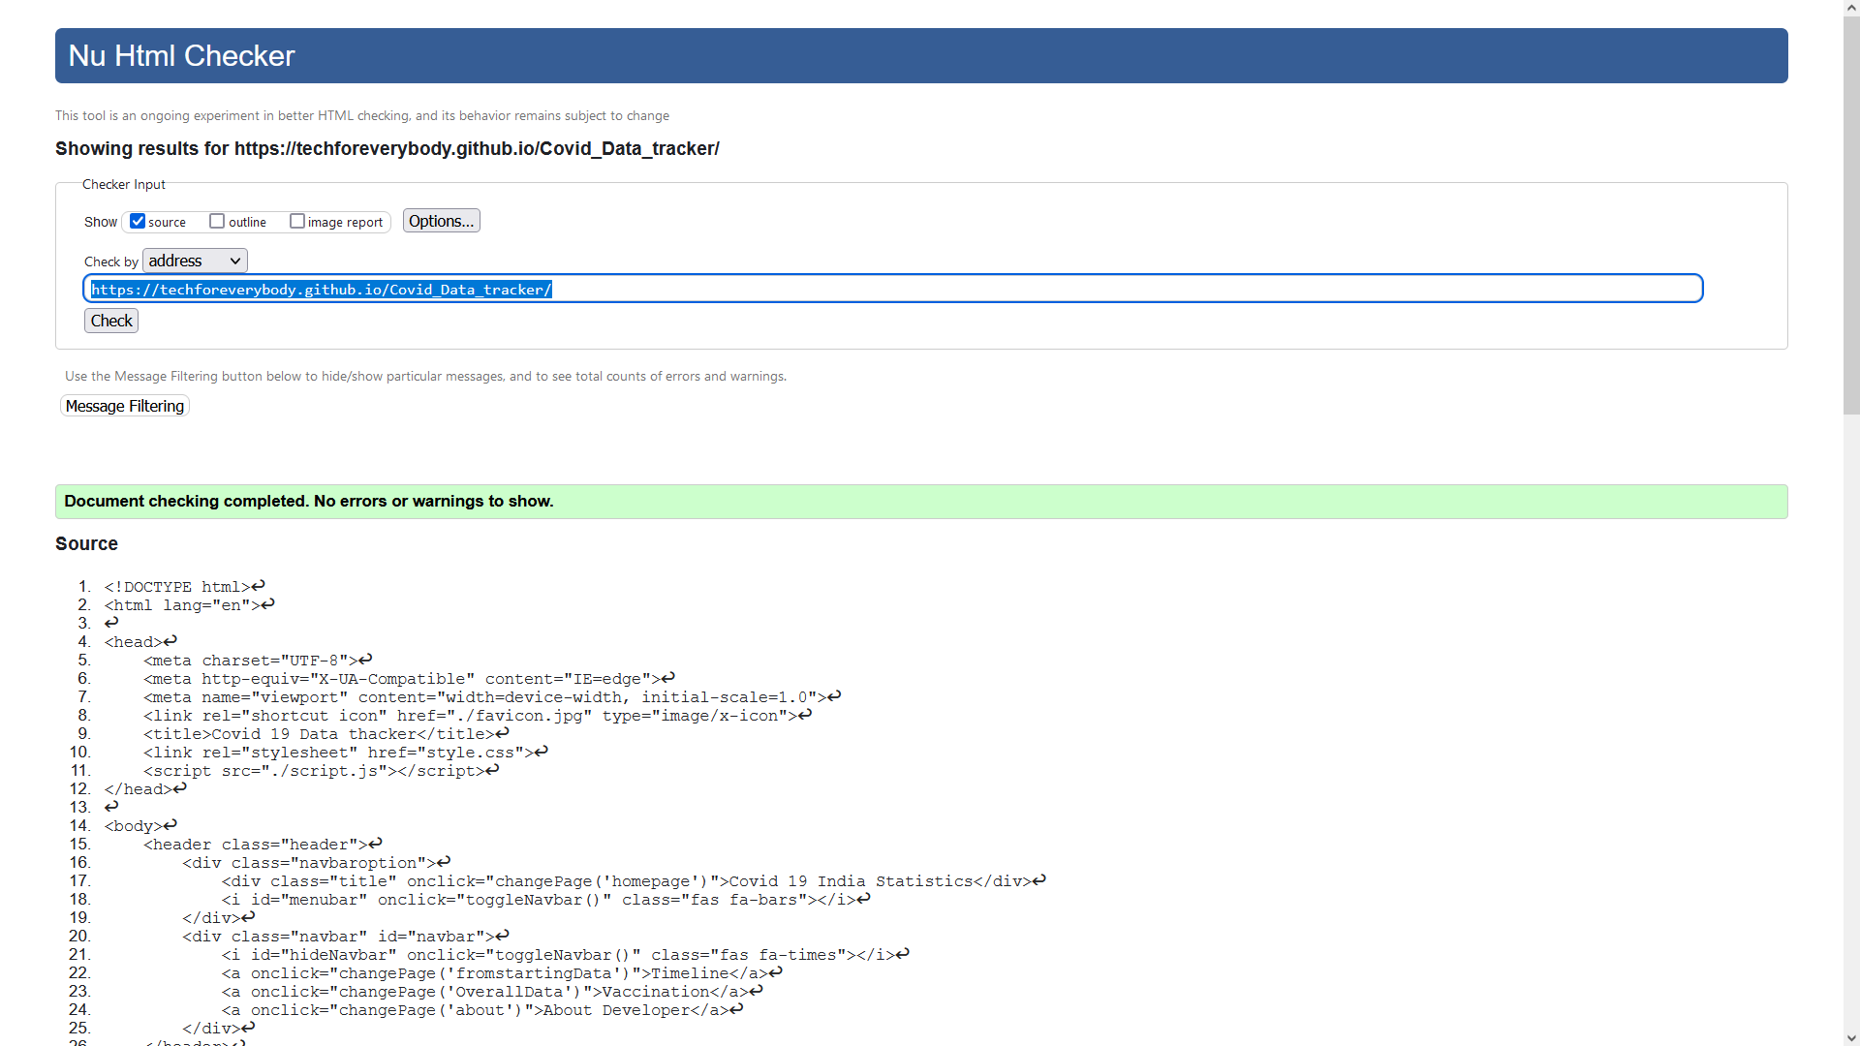

1. Responsiveness And 3. CSS stylings

Desktop Mode Screenshots

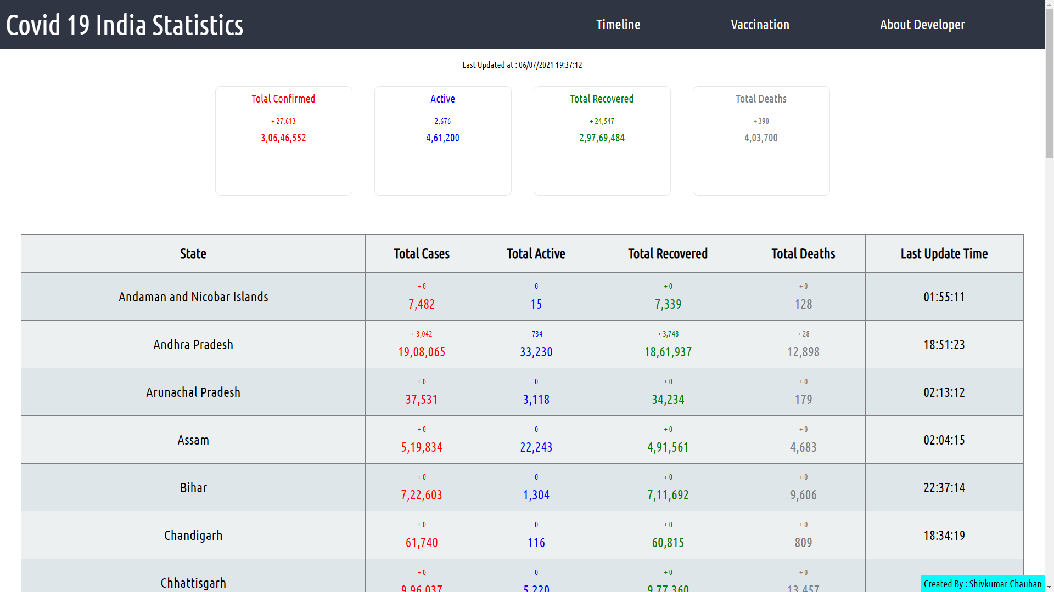

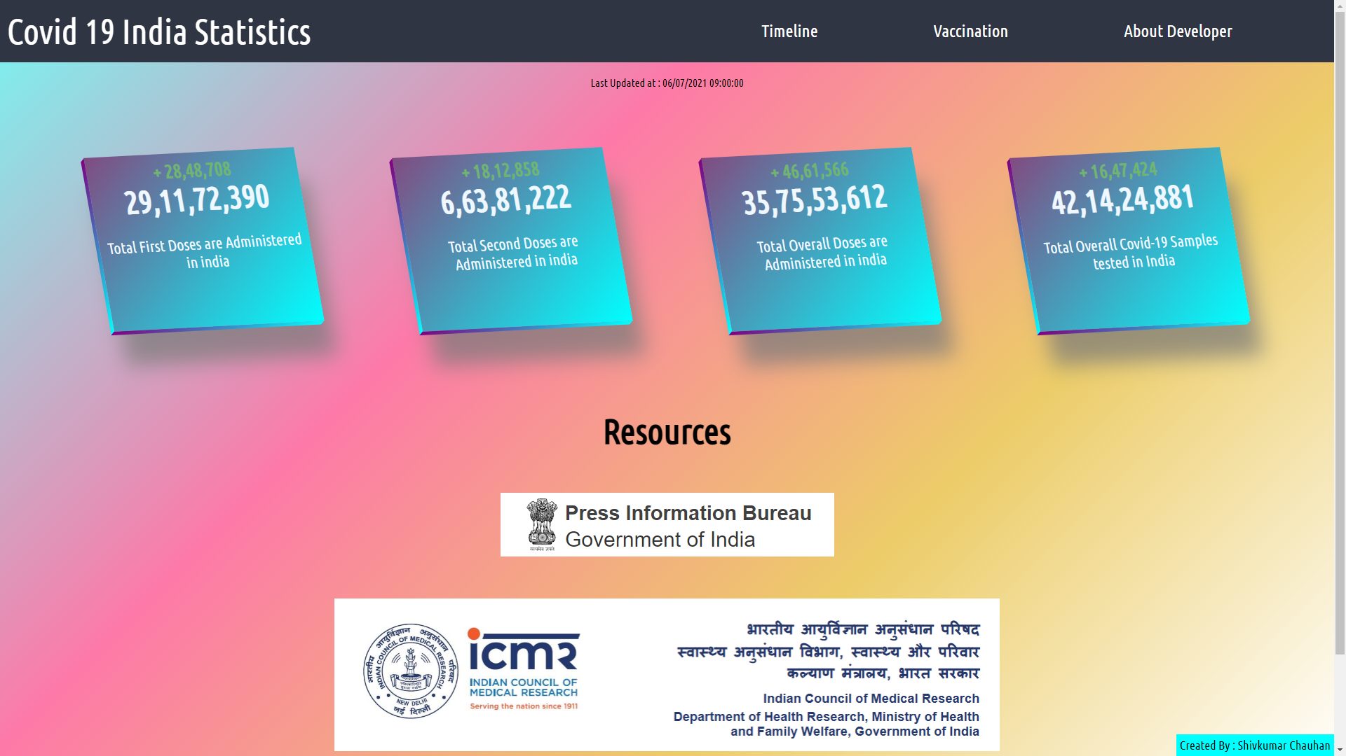

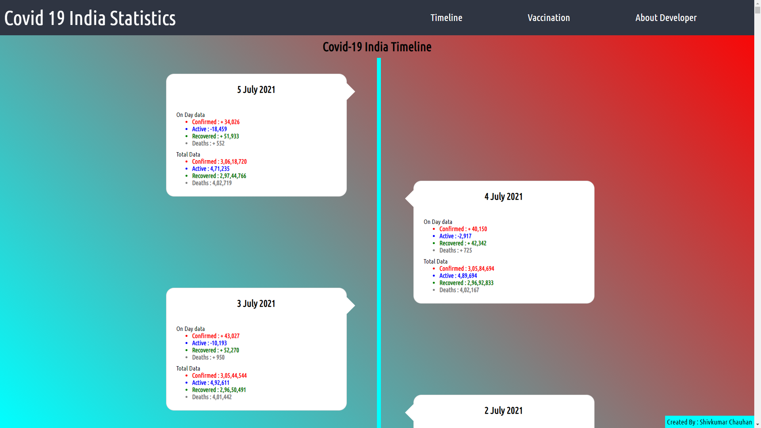

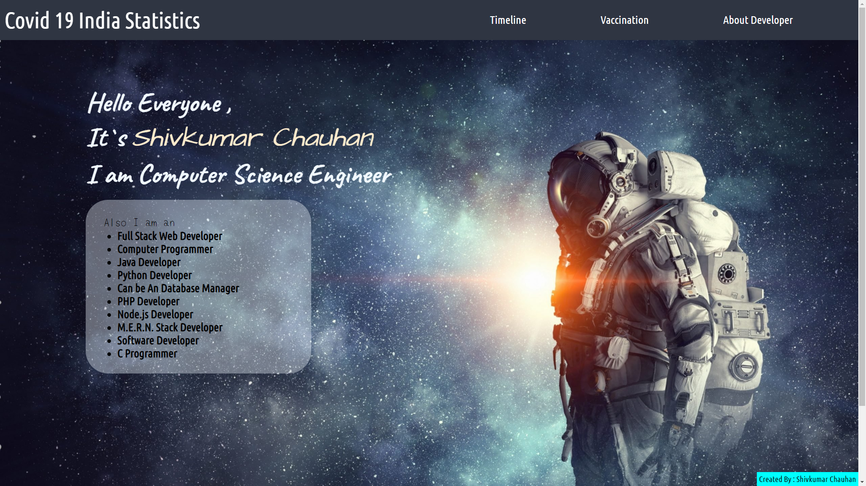

Mobile Mode Screenshots

